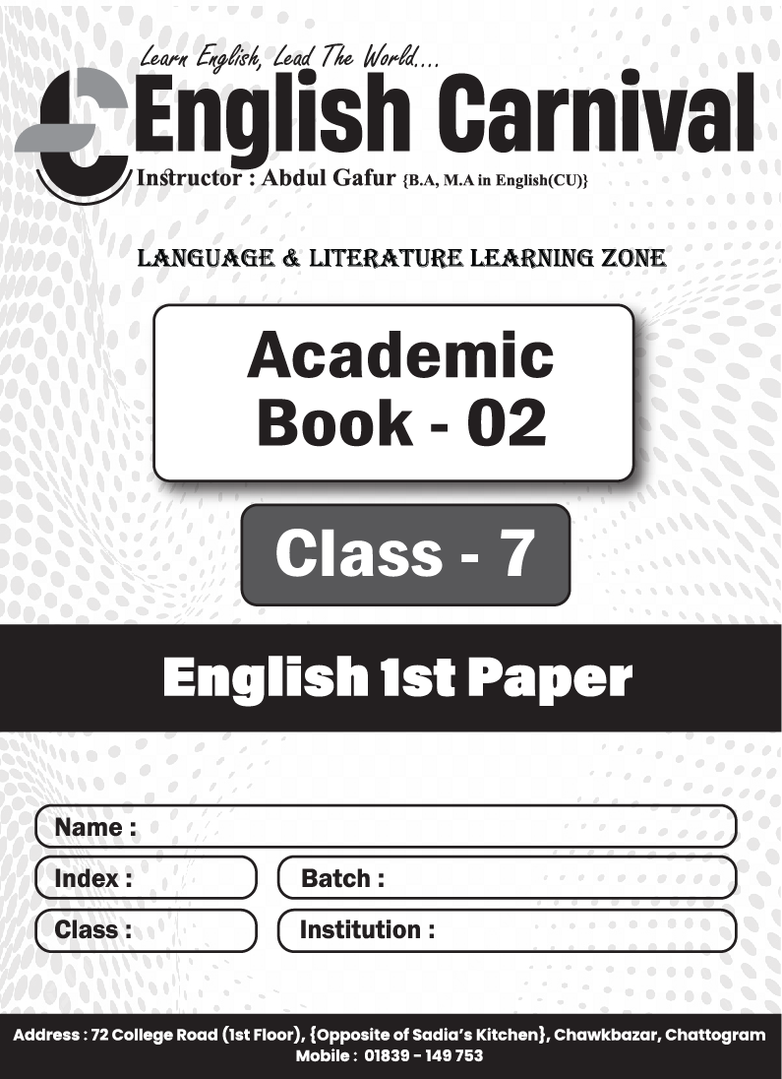

Model Test-01
Part-A : Grammar (Marks-30)
- Fill in the blanks with the words from the box. You may need to change the form of the words. You may need to use one word more than once. 0.5  10 = 5
the | in | to | every | inherent | or | a | must | patriot
Patriotism is a noble virtue. It is an (a)___ instinct in human nature. It inspires a man to shed (b)___ drop of blood (c)___ defend the liberty and dignity of the country. But patriotism should not be merely (d) ___ so-called slogan in the public meeting (e)___ fraud the people. It should be remembered is (f)___ core of heat and materialized (g)___ our deeds. We should keep ourselves above from the fake (h)___ Everybody should bear in mind that a pretender (i)___ be defeated. Nobody will remember (j)___ honour a mock patriot,
Or, Smoking is (a)___ extremely bad habit. Those who are addicted (b)____ smoking fall (c)____ different types of problems. They suffer from (d)___ deadly diseases. Besides, by smoking they waste money (e)___ large scale. So, the smokers should give up (f)___ bad habit. They should do it for their own health and future. Otherwise, their life will be nothing but (g)___ waste. The smokers should also keep (h)___ mind that they are creating hazard for the (i)___ while they smoke in front of them. They should get rid (j)___ this selfish act.
- Make five sentences using parts of sentences from each column of the table below. 1  5 = 5
Happiness | may  is  varies | not be happy.
A person with a crown | may  is  varies | a relative term.
Whereas a day labourer | may  is  varies | from person to person.
Again, happiness | may  is  varies | a blessing of God.
Complete happiness or peace of mind | may  is  varies | find happiness living in a shabby hut.
- Fill in the gaps with the right forms of verbs in the brackets. 1 × 5 = 5
A school magazine (a)___ (play) an important role in school life. It is different from other regular journals. Our school magazine is (b)___ (publish) in English language. The editor of the magazine is a student who (c)___(act) under the supervision of a teacher. The magazine (d)___ (introduce) the writers who (e)____(find) opportunity to express their thoughts and ideas.
- Change the narrative style of the following sentences. 1 × 5 = 5
- He says to me, “You’re a lucky person.”
- The boy said, “I read about Abu Sayeed’s contributions to anti-discrimination movement last night.”
- The teacher said to me, “Have you ever visited the historic city of Paharpur?”
- The teacher said, “Please write about the struggle for independence in Bangladesh.”
- The man said, “I am going to attend a wedding ceremony in my village.”
- Read the following text and change the sentences directed. 1 × 5 = 5
(a) A day labourer is known to everyone. (Make it active) He lives with his family in a slum. (b) He is not lazy and apathetic. (Make it affirmative) (c) He is always dependent on his employer. (Make it negative) His service is very important. But (d) he is neglected in the society. (Make it interrogative) (e) Let's be respectful to day labourers. (Make it assertive)
- Use appropriate punctuation marks and capital letters where necessary. 5
can you tell me why I have come to see you today it is not what you are thinking i have come here to say hello by the way do you know where Alif lives now
Part-B : Writing (Marks-20)
- Learning English helps one to reach the definite goal of success. Suppose, your friend is not willing enough to learn this language properly. Now, write a letter to your friend telling him about the usefulness of learning English. 8
- Write a short composition on 'Physical Exercise' in about 250 words. 12

